**EXPERIMENT-1**

**Introduction to SAM Software**

**AIM:** To understand the performance/behavior of a system, generating or loading data from sources, testing, and working of System Advisor Model (SAM) software.

**Software Details:**

SAM functions as a software system specialized in financial modeling, serving to conceptualize and assess the expenditure implications tied to energy production and consumption. The ensuing compilation showcases the diverse applications of SAM in the realm of modeling:

• Systems for generating electrical power.

• Technologies encompassing Li-ion and lead acid batteries, photovoltaic setups, as well as fuel cells.

• Ventures centered around geothermal power generation.

• Equipment such as solar water heaters, marine energy solutions including wave and tidal systems, wind power installations, and more.

• Initiatives involving biomass combustion to fuel power generation.

In addition to these, SAM can be seamlessly integrated into the subsequent project categories:

1. Implementations for residential and commercial purposes where a system is deployed on the consumer side of the utility meter, consequently curbing the consumer's electricity expenses.

2. Arrangements based on third-party ownership models, wherein the meter is positioned on the property of the host but overseen by a distinct entity. Compensation for the host materializes through power purchase agreements (PPAs) or lease accords.

**Steps:**

1. Navigate to the URL https://sam.nrel.gov/. From there, procure the latest software version tailored to your operating system (OS). Dedicated links are provided for various OS options like Linux, Windows, and more.

2. Once the download is complete, launch the software to be welcomed by an initial interface. opt for the 'Begin a New Project' choice. Given our experiment's focus on solar water heating, proceed to select the 'LCOE Calculator (FCR method)'.

3. Within the 'Download Weather Files' section, pinpoint a geographic region. For instance, for this experiment, we will go with Ahmedabad. After acquiring and integrating the data into your library, you will gain access to the ensuing display:

1. **Download and install software.**

1. **Load weather file for a location.**

* Select location: Ahmedabad.
* Download and load weather file.

1. **Choose a performance model, financial model, and simulation.**

Performance Model: PV Watts

Financial Model: Single Owner

**Simulation**

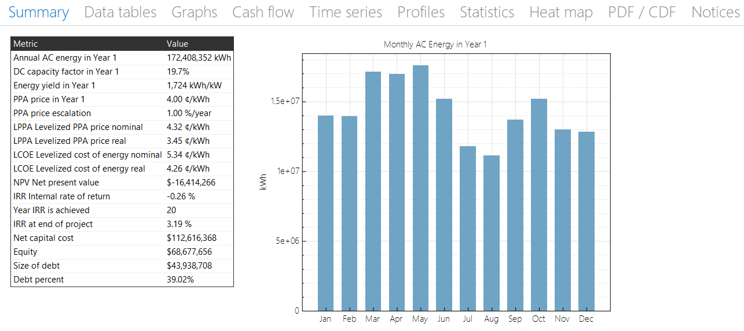

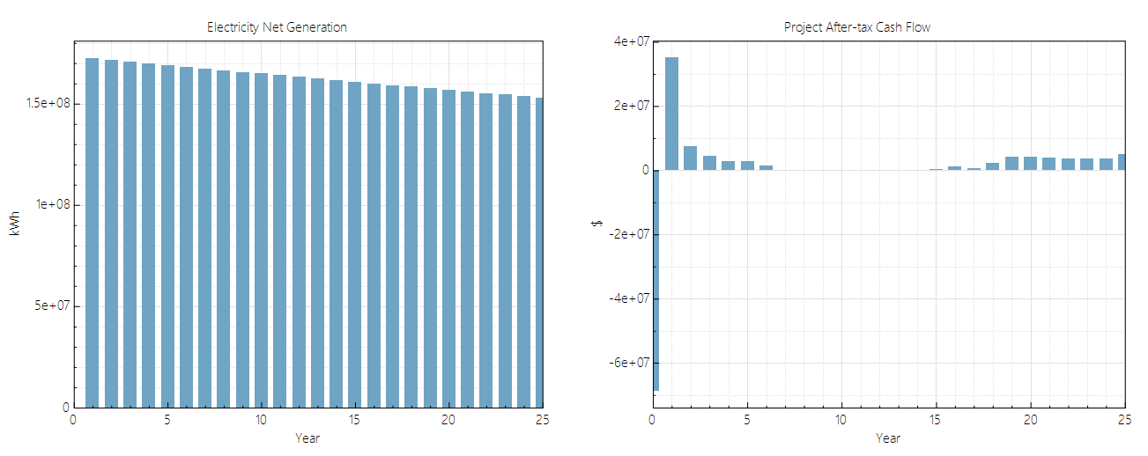

1. **Analyze the simulation results based on any 10 performance characteristics.**

* Annual AC Energy in Year 1 (kWh): **172,408,352 kWh**
* This value represents the total amount of electrical energy generated by the solar powerplant in the first year of operation. It indicates the overall output ofthe solar panels.
* Energy Yield in 1 Year (kWh/kW): **1,724 kWh/kW**
* Energy yield is the amount of electricity generated per unit of DC capacity. In this case, the solar power plant generates 1,724 kWh of electricity for every 1 kW of DC capacity.
* DC Capacity Factor in Year 1 (%): **19.7%**
* The DC capacity factor is a measure of how efficiently the solar panels convert sunlight into electricity. It represents the actual energy output as a percentage of the maximum possible output.
* PPA Price in Year 1 ($/kWh): **$4/kWh**
* PPA (Power Purchase Agreement) price is the amount of money paid by a buyer for each unit of electricity generated by the solar power plant. In this case, the initial PPA price is $4 per kWh.
* PPA Price Escalation (%): **1.00%**
* This value represents the annual increase in the PPA price. The PPA price is expected to increase by 1% each year.
* LPPA Levelized PPA Price Nominal ($/kWh): **$4.32/kWh**
* LPPA (Levelized Plant Price Agreement) is the average price at which electricity needs to be sold over the project's lifetime to recover all costs and achieve a target rate of return, considering the PPA escalation.
* LPPA Levelized PPA Price Real ($/kWh): **$3.45/kWh**
* This is the same as the LPPA price, but adjusted for inflation and expressed in real terms, providing a more accurate representation of future revenue.
* LCOE Levelized Cost of Energy Nominal ($/kWh): **$5.34/kWh**
* LCOE (Levelized Cost of Electricity) is the average cost per unit of electricity generated over the project's lifetime, including all costs such as capital, operations, and maintenance.
* LCOE Levelized Cost of Energy Real ($/kWh): **$4.26/kWh**
* Similar to the LPPA values, this is the LCOE adjusted for inflation and expressed in real terms.
* Net Capital Cost ($): **$****112,616,368**

This is the total cost of building the solar power plant, accounting for factors such as equipment, installation, and other associated costs, minus any subsidies or incentives.

1. **Compare the potential and performance of same technology at two different locations.**

Technology: PV Watts, Single Owner

1st location: Ahmedabad (analysis done previously)

2nd location: Bangalore

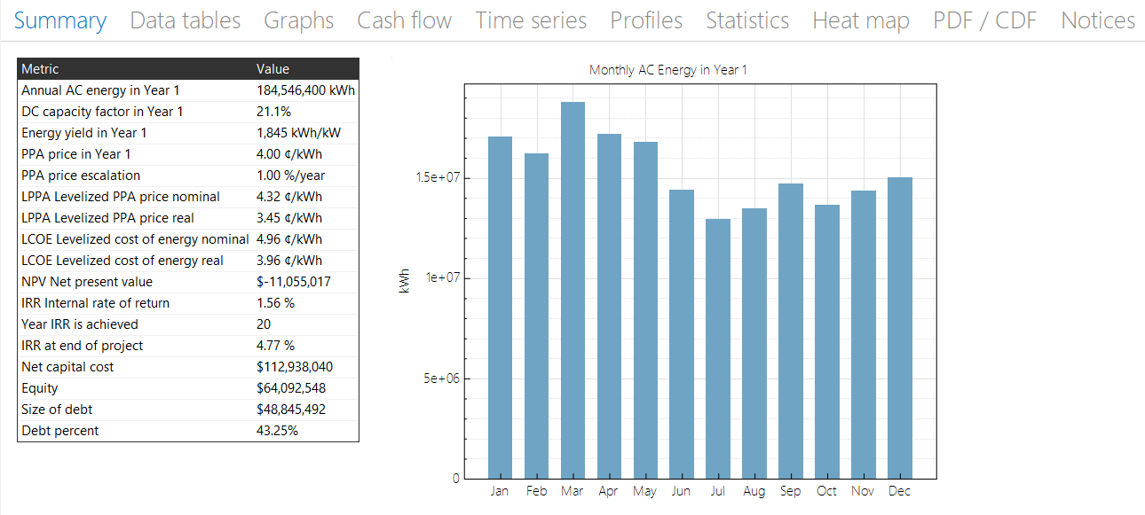

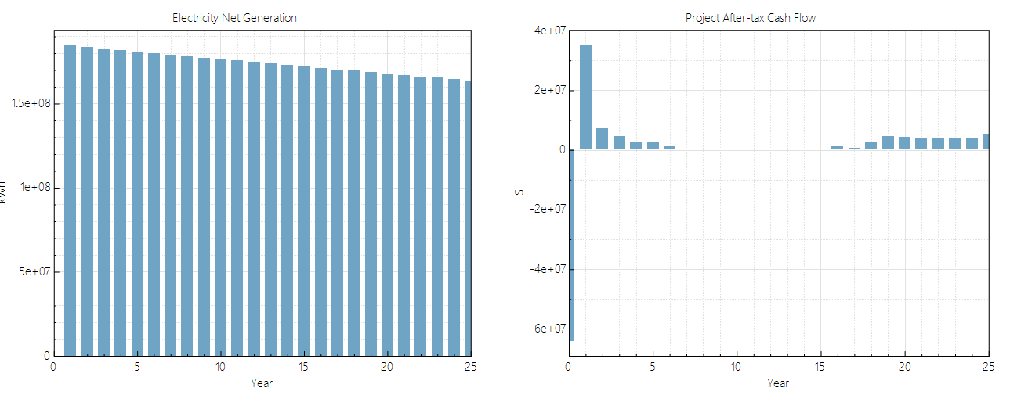

**Analysis/ Evaluation:**

• Year 1 Annual AC Energy (kWh): 184,546,400 kWh

• Energy Yield within 1 Year (kWh/kW): 1,845 kWh/kW

• Initial Year 1 DC Capacity Factor (%): 21.1%

• Year 1 Power Purchase Agreement (PPA) Rate ($/kWh): $4/kWh

• Annual PPA Rate Escalation (%): 1.00%

• Levelized PPA Price (LPPA) in Nominal Terms ($/kWh): $4.32/kWh

• Real Levelized PPA Price (LPPA) ($/kWh): $3.45/kWh

• Levelized Cost of Energy (LCOE) in Nominal Terms ($/kWh): $4.96/kWh

• Real Levelized Cost of Energy (LCOE) ($/kWh): $3.96/kWh

• Net Capital Expenditure ($): $112,983,040

**Conclusion:**

To begin with, in the realm of annual AC energy generation, Bangalore takes the lead with a robust output of 184,546,400 kWh, surpassing Ahmedabad's 172,408,352 kWh. This heightened energy yield in Bangalore can be ascribed to its superior DC Capacity Factor of 21.1% in the first year, in contrast to Ahmedabad's 19.7%.

Interestingly, despite the divergence in energy yield, both cities share identical PPA prices for year 1, coupled with an annual 1% PPA price escalation. This convergence results in equivalent figures for both cities when it comes to levelized PPA price in nominal and real terms (4 for both).

Shifting to the levelized cost of energy (LCOE), Bangalore stands out with a more modest nominal LCOE of 4.96, in comparison to Ahmedabad's 5.34. Similarly, the real LCOE for Bangalore (3.96) is more favorable than Ahmedabad's (4.26), underscoring the cost-efficiency of energy production in Bangalore.

Remarkably, both cities showcase comparable net capital costs for their respective solar ventures. Bangalore's outlay of 112,983,040 slightly surpasses Ahmedabad's 112,616,368.

In a nutshell, while Bangalore takes the lead in energy production and boasts favorable LCOE metrics in contrast to Ahmedabad, both locales share akin PPA conditions and net capital expenses. This comparative analysis implies that Bangalore's solar energy initiative could potentially yield greater economic efficiency and productivity over time, attributed to its superior energy yield and more economical LCOE. Nonetheless, it is imperative to consider specific regional nuances and variables that could impact the overall viability and triumph of each solar project.